**Criterion B: Design**

Product Development Plan:

#1 Creating a Spreadsheet class

* Create a class to store the user’s spreadsheet information
* Use arrays to contain the name of the spreadsheet, date, item/description, income, outcome, and balance
* Ensure that the array is properly printed in a table format

#2 Creating a Display Spreadsheet class

* Create a class that displays the given spreadsheet in a table format
* Takes in user-input and sets the contents of the spreadsheet
* Allows the user to modify any information that is incorrectly put in
* Returns the overall balance by finding the difference between income and outcome
* Generates monthly and yearly expenses

#3 Develop a method to save the spreadsheet

* On button click, the current spreadsheet can be saved as an Excel workbook
* Spreadsheets that have already been saved can be easily loaded in the menu

#4 Creating a Menu:

* Allows the user to create a new spreadsheet or choose from an existing one
* Allows the user to name their spreadsheets accordingly
* The user can log out of the program here

#5 Creating a Login/Register Class:

* Prevents others from stealing personal/financial information
* Allows user to input corresponding username and password to access the program
* Allows user to create a new account if it’s their first time using the program

Current UML Diagram: (Full Updated UML Diagram found in Appendix B)

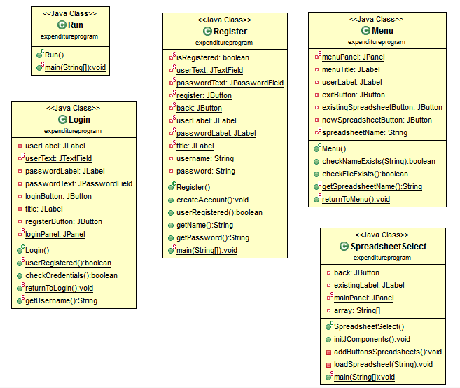

Software Design:

Log Out

Existing Spreadsheets

User chooses one of the existing spreadsheets

Back

Spreadsheet 2

Spreadsheet 3

Personal Expenses

Prompts the user for the title of the spreadsheet and creates one

View Existing Spreadsheet

Create New Spreadsheet

Household Expenditures Main Menu

Sign Up

Enter password again

Password

Create a username

If passwords don’t match, an error message will appear.

If login and password do not match, an error message will appear.

Household Expenditure Spreadsheet

Sign Up

Log In

Password

Username

|  |  |  |  |  |  |
| --- | --- | --- | --- | --- | --- |
| Date | Item/Description | To/From | Income | Outcome | Balance |
| August 1 2020 | Payday | Work | 500.00 |  | 720.00 |
| July 18 2020 | School Material | Dollarama |  | 10.00 | 220.00 |
| July 15 2020 | Fancy Dinner | Best Restaurant |  | 250.00 | 230.00 |
| June 12 2020 | Fast food | McDonald’s |  | 20.00 | 480.00 |
| June 1 2020 | Payday | Work | 500.00 |  | 500.00 |

Example:

Spreadsheet is automatically sorted by most recent date

Name of the spreadsheet is listed on top left corner

Main Menu

Save

Add

Personal Expenses Overview

Day

Year

Year

Day

Automatically prints out the user’s balance every time based on income and outcome.

Save Changes

Delete

Edit an Item

Add an Item

Cancel

Add

User can choose to delete an entire row

If the user entered an Item/Description and names in To/From in the spreadsheet, these entries are saved and can be easily chosen again by the user

Year, Month, and Day are selected using a drop-down menu, limiting user error

Outcome

Income

To/From

Item/Description

Month

Month

Item/Description

Outcome

Income

To/From

Edit

Program’s Working Plan (process description):

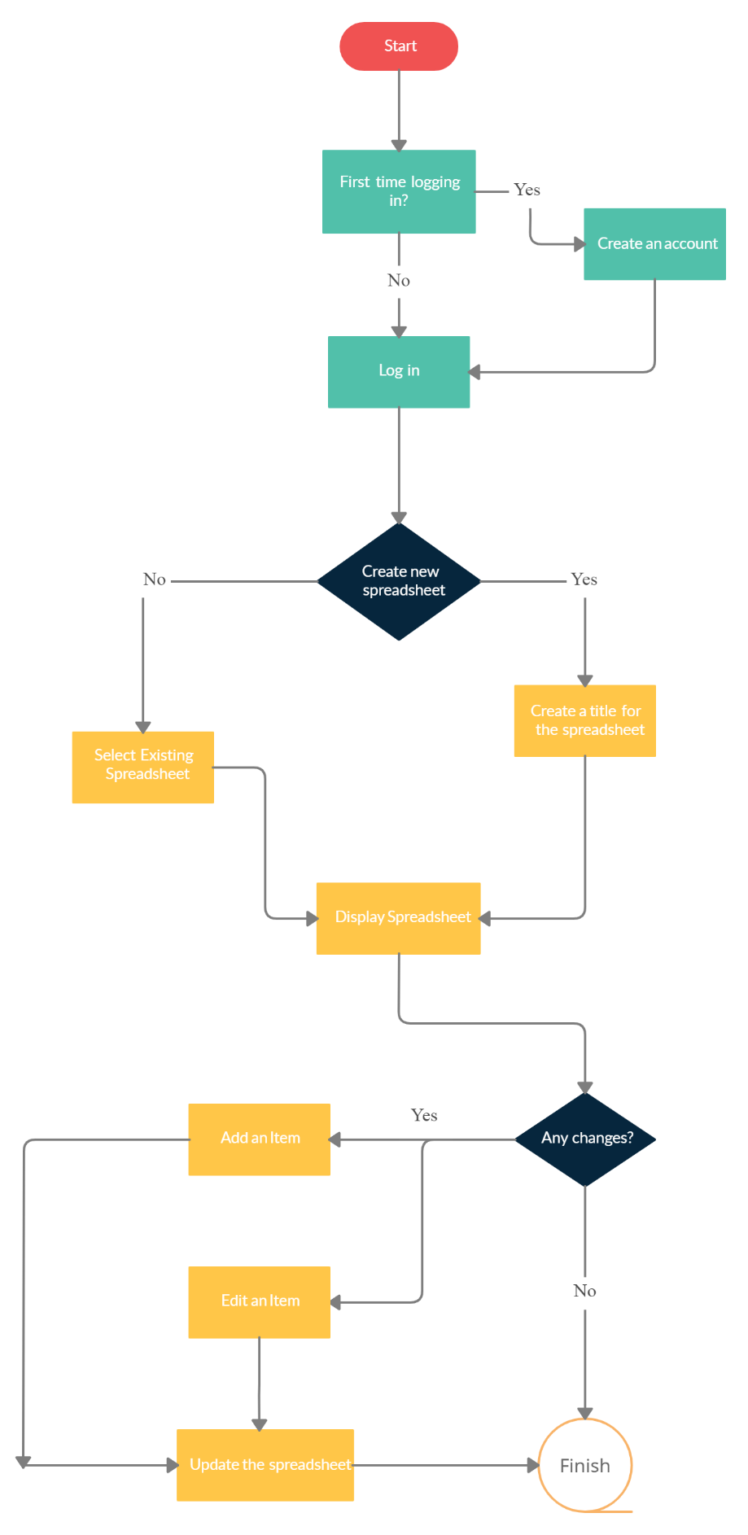

Input Data:

|  |  |
| --- | --- |
| Data 1  Client selects “Sign Up”, proceeds to create a username and password. Last field requires the client to re-enter the password.  Afterwards, the client uses the credentials that they just entered to use the program.  Example:  Username: MyFamily  Password: expenses | Comment:  The contents in the password text fields are compared with each other to determine whether they are the same. If not, an error message will appear.  Location:  Once the username and password is verified, a text file will be created storing the username and password. |
| Data 2  Client chooses to create a new spreadsheet and is prompted to enter the name that he/she wishes to call it. | Location:  A text file with the name of the spreadsheet is created.  Comment:  The program automatically creates a new item with the description stating the spreadsheet has been created. |
| Data 3  Client chooses to add a new item into the spreadsheet.  Example: (assume balance is set to $10)  Day: 12  Month: June  Year: 2020  Item/Description: Pizza Lunch  To/From: John’s Pizza  Income: 0  Outcome: 10.00  Output:  June 12 2020 – Pizza Lunch – John’s Pizza – 0 – 10.00 – 0.00  (as shown in the example above) | Location:  Text file will be modified to include the user’s entry  Comment:  If the item/description was previously stored in the database, the user can choose to select it again from a drop-down menu. This function would work for the “To/From” text field as well. |

Output Data

1. The specific spreadsheet is displayed, sorted by most recent date.

2. Error messages will be outputted if there are conflicting pieces of information (username and password).

|  |  |  |  |
| --- | --- | --- | --- |
| Test Number | Description | Instructions | Expected Results |
| 1 | Logging into the program | To use the program, the user must log in with their credentials. | The user is able to log into the main menu if credentials are correct. Otherwise, they are stuck on the security page. |
| 2 | Selecting main menu options | The user can choose one of two options:  1. Create a new spreadsheet  2. View existing spreadsheet | If the user chooses option 1, the program prompts the user for the name of the spreadsheet and displays it.  If the user selects option 2, a tab will open with a menu of existing spreadsheets. The user selects a spreadsheet and displays it. |
| 3 | Displaying the spreadsheet  1. Add an item  2. Edit an item. | 1. By using this button, an “add an item” window will appear and allow the user to fill in the required fields  2. By selecting this button, an “edit an item” button will appear and allow the user to modify their existing items | The expected result after using the two buttons is that the spreadsheet will be updated with the given information. |
| 4 | Checking if monthly expense and yearly expenses are calculated | User updates the given spreadsheet | The monthly total and yearly total of the expense should change and reflect on the user’s new input. |
| 5 | Income and outcome values are not doubles | User inputs an invalid datatype, for example enters a string instead of a double | The program will prompt the user to enter a positive double value for both input and output. |
| 6 | Check “log out” function | Run the program from the main menu or the spreadsheet window and click the “log out” button. | The program should be terminated and all windows should be closed. |
| 7 | Check “save” function | User clicks the “save” button in the spreadsheet | The contents of the spreadsheet will be saved as an Excel file. |
| 8 | Check if previously stored spreadsheets can be called | The user enters a previously stored item or sender/receiver. | The program should output a drop down menu of all the names of previous items and the user can choose from the list provided. |
| 9 | Check “delete” function | The user deletes one of the rows in the spreadsheet. | The program should delete an entire row of the spreadsheet. |

Word count: 261 words